**1.Modelo RF5_Indeg X All var**.

***Instrucciones modelo***: **test size = 0. ; rd_state =**

***Variables indep select to fit***:

variables = ['id', 'PC1_Distance_Pro','Degree_RedeTotFamil', '1_VarExp_Moranca', '5_VarExp_Atri_Idade','Area_bolanha', 'OutDeg_IntimAmigos_', 'OutDeg_RedeConfianc', 'OutDeg_VendaParcela']

***Model performance (scores):***

Mean Squared Error:

R^2 Score: (In Excel: R2 = ; y = )

**Model tot:**

Mean Squared Error (MSE):

Root Mean Squared Error (RMSE):

Mean Absolute Error (MAE):

R^2 Score:

Pearson Correlation:

***Interactions***:

***Key results****:*

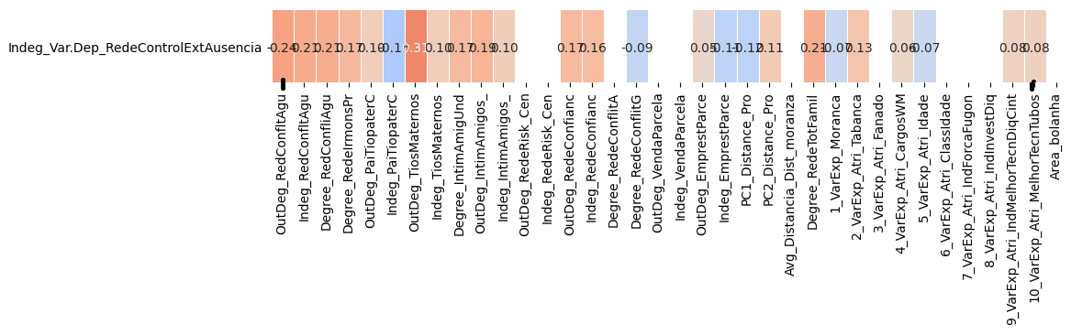

**2.Modelo RF5_Outdeg X All var**.

***Instrucciones modelo***: **test size = 0. ; rd_state =**

***Variables indep select to fit***:

***Model performance (scores):***

Mean Squared Error:

R^2 Score: (In Excel: R2 = ; y = )

**Model tot:**

Mean Squared Error (MSE):

Root Mean Squared Error (RMSE):

Mean Absolute Error (MAE):

R^2 Score:

Pearson Correlation:

***Interactions***:

***Key results****:*